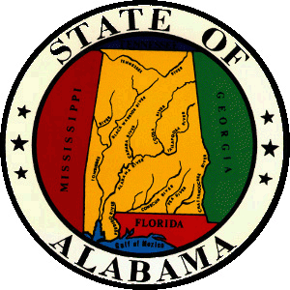 | Alabama Commission On Higher Education  Mailing Address: P.O. Box 302000  Montgomery, Alabama 36130-2000  Delivery Address: 100 North Union Street  Montgomery, Alabama 36104-3758  Telephone: (334) 242-1998  1-800-960-7773  Fax (334) 242-2269  www.ache.edu | 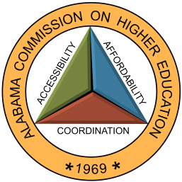

MEMORANDUM

TO: Financial Aid Coordinators
Alabama National Guard Educational Assistance Program (ANGEAP)

FROM: Artcola B. Pettway
Grants and Scholarships Associate

RE: ANGEAP Summer 2022

DATE: April 15, 2022

Great news from the State House!

The legislature has approved and added supplemental budget appropriations to the National Guard Scholarship of $800,000.00 where we believe should be able to cover the cost of Summer coursework for National Guard students. We estimate that this funding will be sufficient to cover student’s cost; if not, ACHE will establish a protocol to address the issue. Please communicate to all appropriate staff and students that qualify for the ANGEAP Scholarship so they can make plans for the Summer Term based on this new information.

As always, please be prompt when submitting applications and request forms. Summer 2022 reimbursements will be paid as received by the deadline date of 6/27/2022. Summer applications received at ACHE after the deadline date will not be paid.

Please, do not submit Fall and Spring applications with the Summer requests for reimbursements.

Feel free to contact me at (334)353-0985 or at artcola.pettway@ache.edu if you have any questions.

