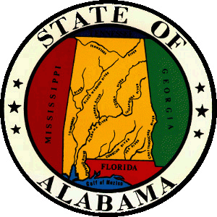 | Alabama Commission On Higher Education  Mailing Address: P.O. Box 302000  Montgomery, Alabama 36130-2000  Delivery Address: 100 North Union Street  Montgomery, Alabama 36104-3758  Telephone: (334) 242-1998  1-800-960-7773  Fax (334) 242-2269  www.ache.edu | 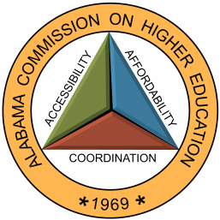

MEMORANDUM

TO: Financial Aid Coordinators
Alabama National Guard Educational Assistance Program (ANGEAP)

FROM: Artcola B. Pettway
Grants and Scholarships Assistant

RE: ANGEAP Summer 2022 Award Reimbursements

DATE: March 8, 2022

As you are aware, the sufficiency of ANGEAP funding required to pay for Summer term reimbursements has been on a declining trend in providing each eligible student with a full grant payment for their Summer coursework. Due to limited appropriated funds for the 2021-2022 fiscal year, payments for Fall 2021 and Spring 2022 coursework have nearly exhausted annual appropriations. As such, the impact of this deficit has caused remaining available funds for Summer 2022 reimbursements to be insufficient to fully cover costs of Summer coursework for prospective eligible students. Therefore, please be advised that ACHE will not process ANGEAP application requests for the Summer 2022 term.

Please make certain all appropriate staff and the student body community are made aware of this decision prior to the beginning of the Summer enrollment period.

Should you have any questions, please contact me at (334)353-0985 or at artcola.pettway@ache.edu.

